K2 comparison

Idea
The extended source size correction factor can be calculated using the vendor-provided polynomial factor formula, using the approximation formula for uniform illumination, or using the direct integration of the radiation pattern.

Polynomial factors
Polynomial factors are taken from Viasat K2 polynomial approximation formula for X-band antennas.
The polynomial formula is following:
$$K_{2}=a_{0}θ_{d}{f_{GHz}}^{2}+a_{1}f_{GHz}+a_{2}{f_{GHz}}^{2}+a_{3}f_{GHz}+a_{4}θ_{d}f_{GHz}+a_{5}{θ_{d}}^{2}f_{GHz}+a_{6}+a_{7}θ_{d}+a_{8}{θ_{d}}^{2}+a_{9}{θ_{d}}^{3}$$

Coefficients | 5.4m | 7.3m | 9.1m | 10.26m | 11.28m
a₀ | 0.22124 | -3.22454 | 0.4137 | 0.5541 | 0.7434
a₁ | -0.00975 | 0.13412 | -1.2490 | -2.9581 | -0.3145
a₂ | 0.16554 | -2.12968 | 31.6666 | 75.1404 | 7.6079
a₃ | -0.57331 | 8.21186 | -269.3682 | -637.2681 | -60.4003
a₄ | -4.52011 | 50.88899 | 1.0325 | -0.6066 | -12.6905
a₅ | 1.64387 | 4.04585 | -5.8184 | -7.3650 | 0.9865
a₆ | -0.21724 | 3.08215 | 776.2878 | 1808.7976 | 153.4486
a₇ | 23.47034 | -201.17202 | -80.5964 | -65.4370 | 66.2610
a₈ | -15.20528 | -30.70381 | 142.7291 | 156.7675 | 12.4544
a₉ | 4.70339 | 4.38388 | -50.1728 | -60.9194 | -17.1503
Table 2: Typical parabolic antenna K2 coefficients

Uniform-illumination approximation
The estimate of extended source size correction factor can be obtained also using the uniform-illumination formulas. In following, two different approximation formulas will be taken into the consideration (i.e. Gaussian far-field antenna pattern).
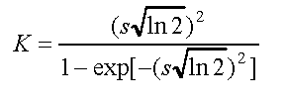 (1) 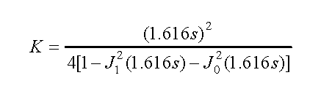(2)

Radiation pattern integration
To integrate radiation pattern, firstly it is important to normalize the pattern in a way that the maximum radiation value is unity (1).
The radiation pattern is presented in the UV grid for easier integration and not neglecting the maximum radiation peak.
Integration has been performed in MATLAB.
For each pattern, the UV grid boundaries were set to [-sin(1°) sin(1°)] inside the 401x401 matrix. Also, in all antennas, the blockage was included and the edge taper was set to -10dB.

Results

Test 1:
- Frequency: 8.25 GHz
- Edge taper: -10 dB
- Blockage: ON
- Antenna design: Cassegrain (reflector f/D = 0.3)
 | K2: Polynomial
 | 0.45° | 0.49° | 0.5° | 0.53° | 0.56°
D=5.4m | 1.4980 | 1.6105 | 1.6411 | 1.7398 | 1.8489
D=7.3m | 1.7665 | 1.9511 | 2.0017 | 2.1674 | 2.3452
D=9.1m | 2.8210 | 3.2951 | 3.4249 | 3.8364 | 4.2748
D=10.26m | 3.7223 | 4.4071 | 4.5825 | 5.1127 | 5.6413
D=11.28m | 4.4423 | 5.2482 | 5.4476 | 6.0393 | 6.6190

 | K2: Approximation 1 (k = 70)
 | 0.45° | 0.49° | 0.5° | 0.53° | 0.56°
D=5.4m | 1.349410 | 1.421457 | 1.440790 | 1.502093 | 1.568533
D=7.3m | 1.686973 | 1.837205 | 1.877837 | 2.007431 | 2.148962
D=9.1m | 2.153688 | 2.417226 | 2.488674 | 2.716714 | 2.965601
D=10.26m | 2.542729 | 2.901084 | 2.998071 | 3.306911 | 3.642501
D=11.28m | 2.946654 | 3.401636 | 3.524367 | 3.913896 | 4.334882

 | K2: Approximation 1 (k = 66.33)
 | 0.45° | 0.49° | 0.5° | 0.53° | 0.56°
D=5.4m | 1.393275 | 1.475140 | 1.497140 | 1.566979 | 1.642795
D=7.3m | 1.778207 | 1.950321 | 1.996921 | 2.145641 | 2.308156
D=9.1m | 2.313583 | 2.616210 | 2.698219 | 2.959767 | 3.244768
D=10.26m | 2.760247 | 3.170941 | 3.281908 | 3.634653 | 4.016837
D=11.28m | 3.223090 | 3.742648 | 3.882435 | 4.325064 | 4.801753

 | K2: Approximation 1 (k = 65.269)
 | 0.45° | 0.49° | 0.5° | 0.53° | 0.56°
D=5.4m | 1.407534 | 1.492617 | 1.515492 | 1.588134 | 1.667030
D=7.3m | 1.808022 | 1.987331 | 2.035891 | 2.190891 | 2.360285
D=9.1m | 2.365942 | 2.681342 | 2.766793 | 3.039231 | 3.335920
D=10.26m | 2.831416 | 3.259085 | 3.374568 | 3.741450 | 4.138570
D=11.28m | 3.313361 | 3.853706 | 3.998961 | 4.458563 | 4.952997

 | K2: Approximation 2
 | 0.45° | 0.49° | 0.5° | 0.53° | 0.56°
D=5.4m | 1.339390 | 1.412012 | 1.431654 | 1.494373 | 1.563088
D=7.3m | 1.687469 | 1.848620 | 1.892834 | 2.035567 | 2.194282
D=9.1m | 2.199630 | 2.502381 | 2.585853 | 2.855563 | 3.154412
D=10.26m | 2.649355 | 3.076590 | 3.193654 | 3.568609 | 3.976719
D=11.28m | 3.13153 | 3.683904 | 3.833227 | 4.304583 | 4.804786

 | K2: Integration
 | 0.45° | 0.49° | 0.5° | 0.53° | 0.56°
D=5.4m | 1.373663 | 1.452669 | 1.474982 | 1.543749 | 1.620254
D=7.3m | 1.763730 | 1.940136 | 1.990593 | 2.147564 | 2.324326
D=9.1m | 2.339701 | 2.670141 | 2.764844 | 3.059009 | 3.387935
D=10.26m | 2.828110 | 3.285913 | 3.416085 | 3.816690 | 4.257118
D=11.28m | 3.351820 | 3.937277 | 4.101727 | 4.601901 | 5.141817

 | HPBW
 | simulation | k = 70 | k = 58.96·(1+0.0125·Te) | k = 58.96·(1+0.0107·Te)
D = 5.4m | 0.451° | 0.471° | 0.446° | 0.439°
D = 7.3m | 0.332° | 0.348° | 0.331° | 0.325°
D = 9.1m | 0.266° | 0.279° | 0.265° | 0.261°
D = 10.26m | 0.235° | 0.248° | 0.235° | 0.231°
D = 11.28m | 0.215° | 0.226° | 0.214° | 0.210°

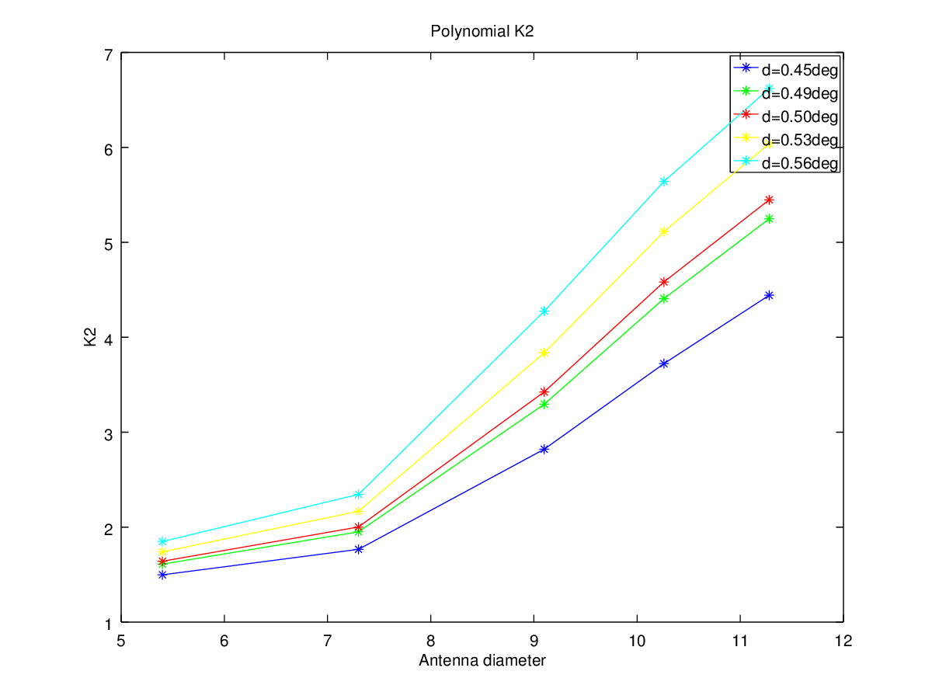
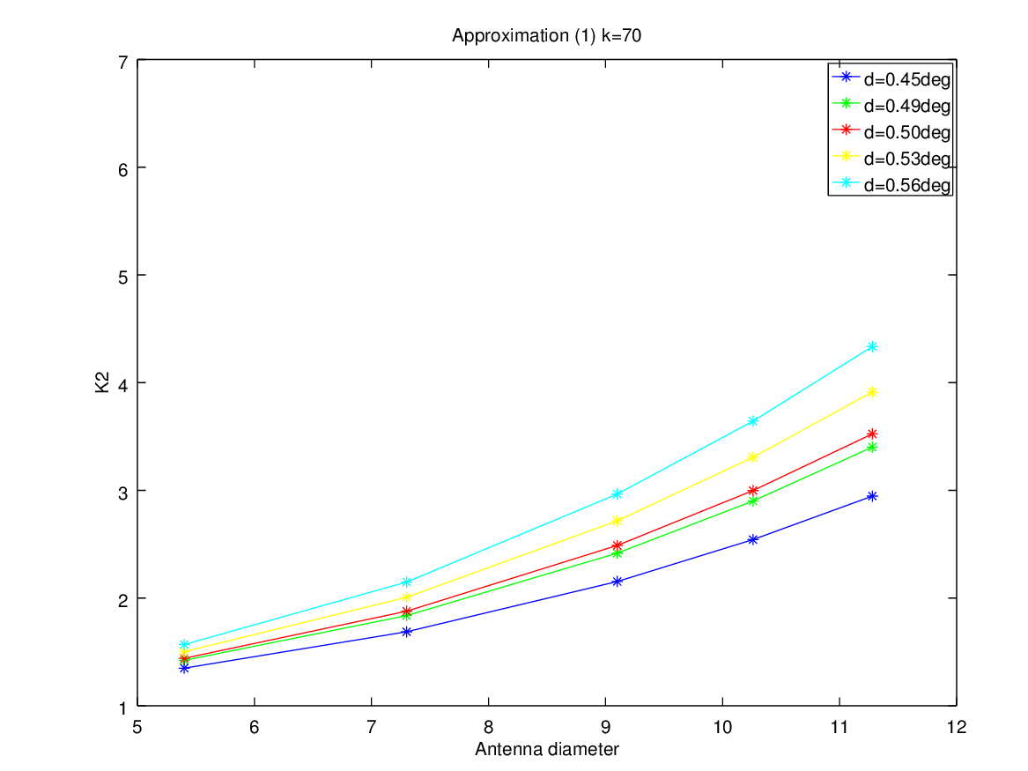
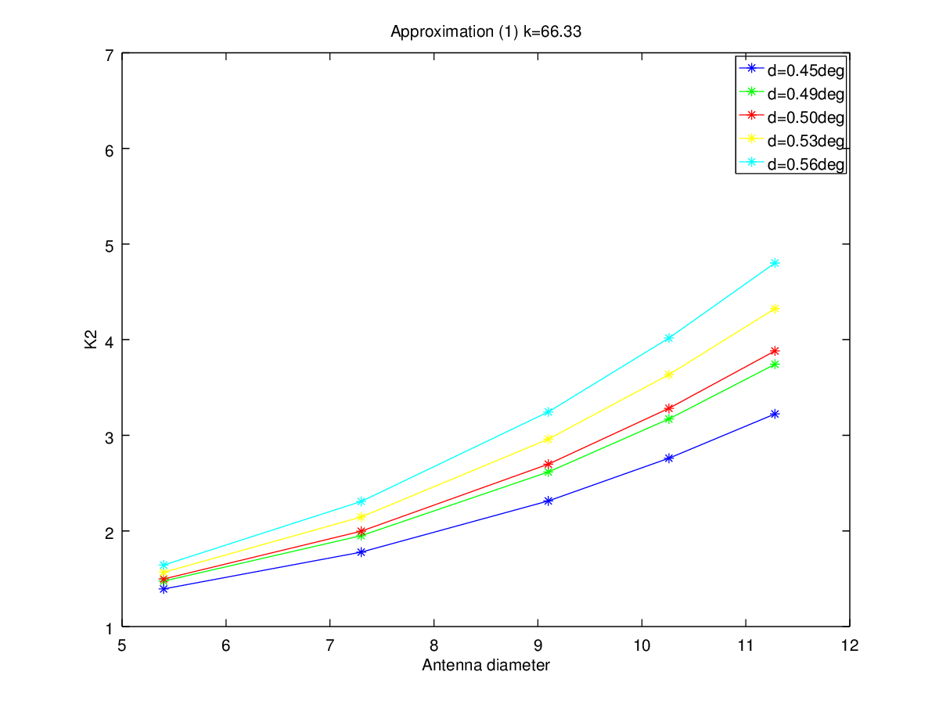
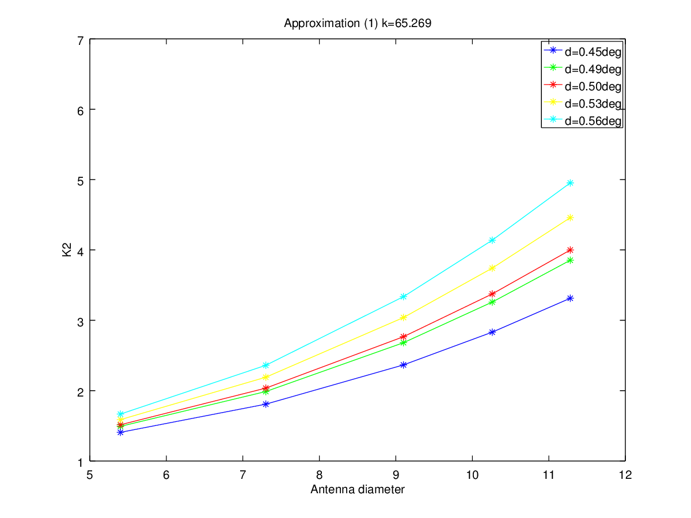
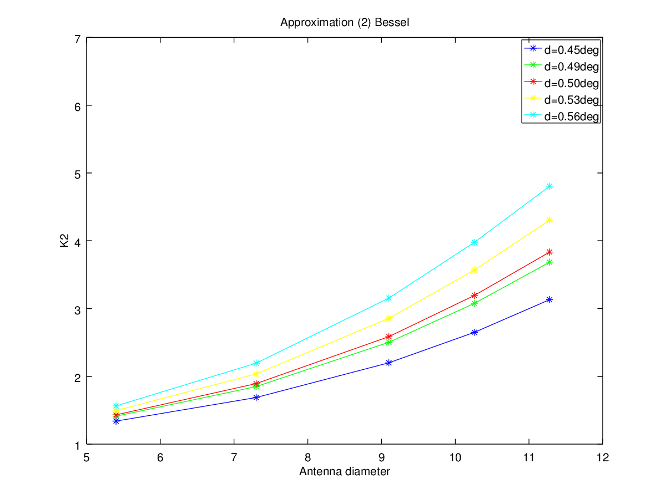
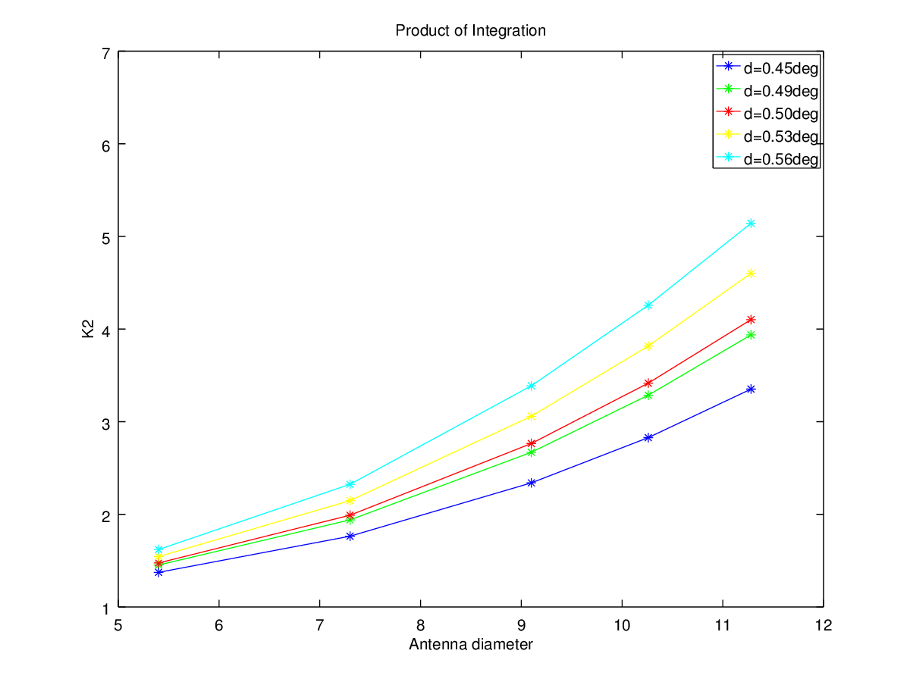
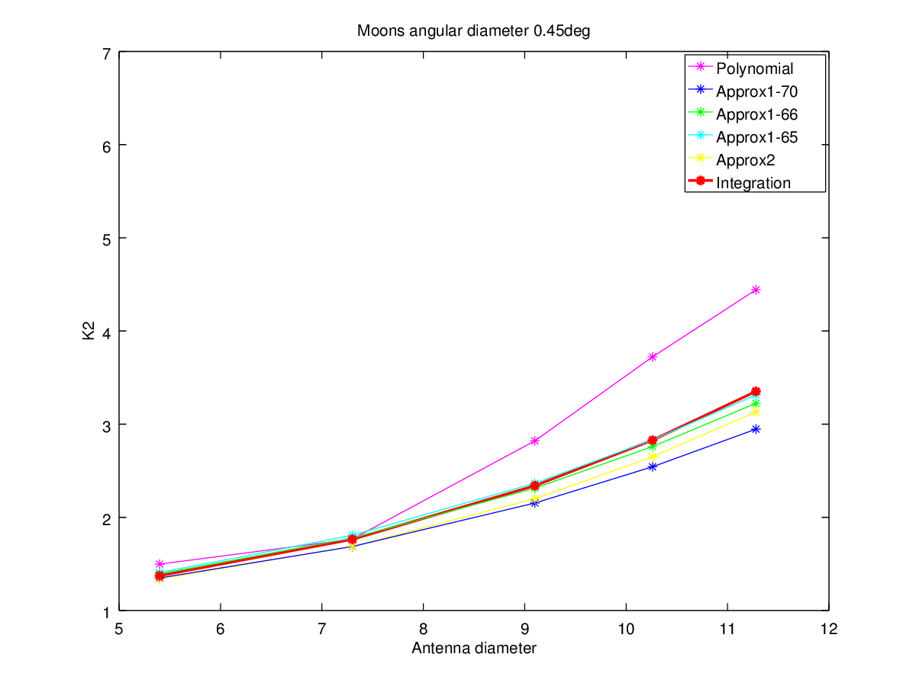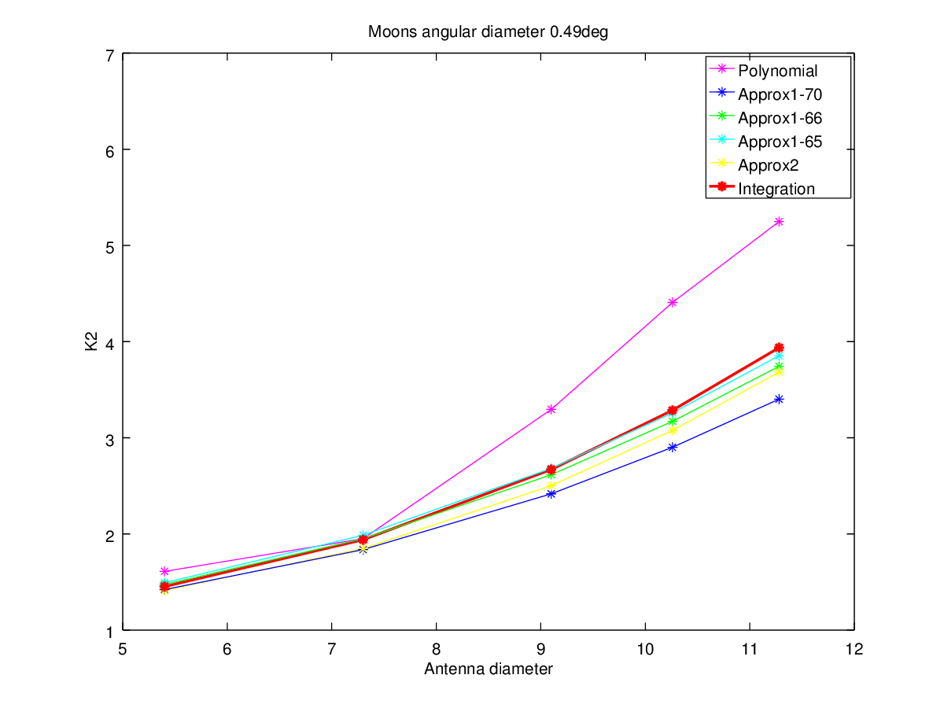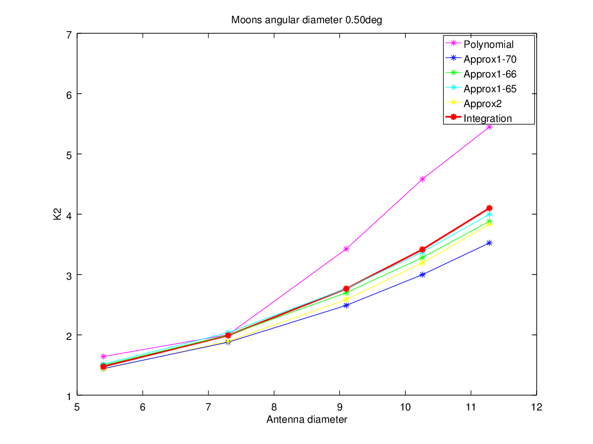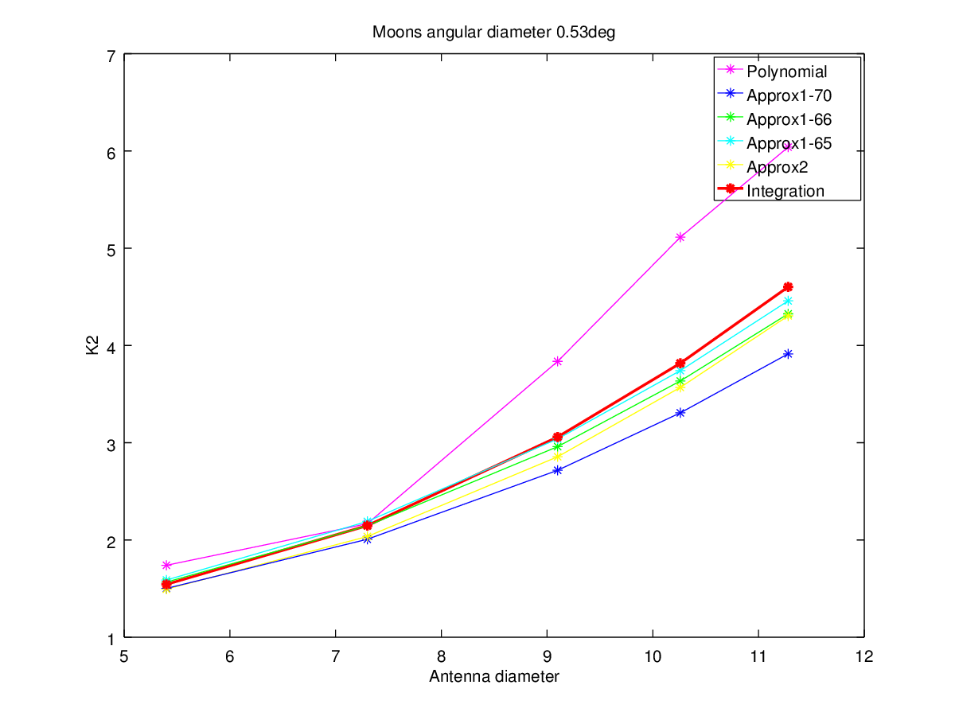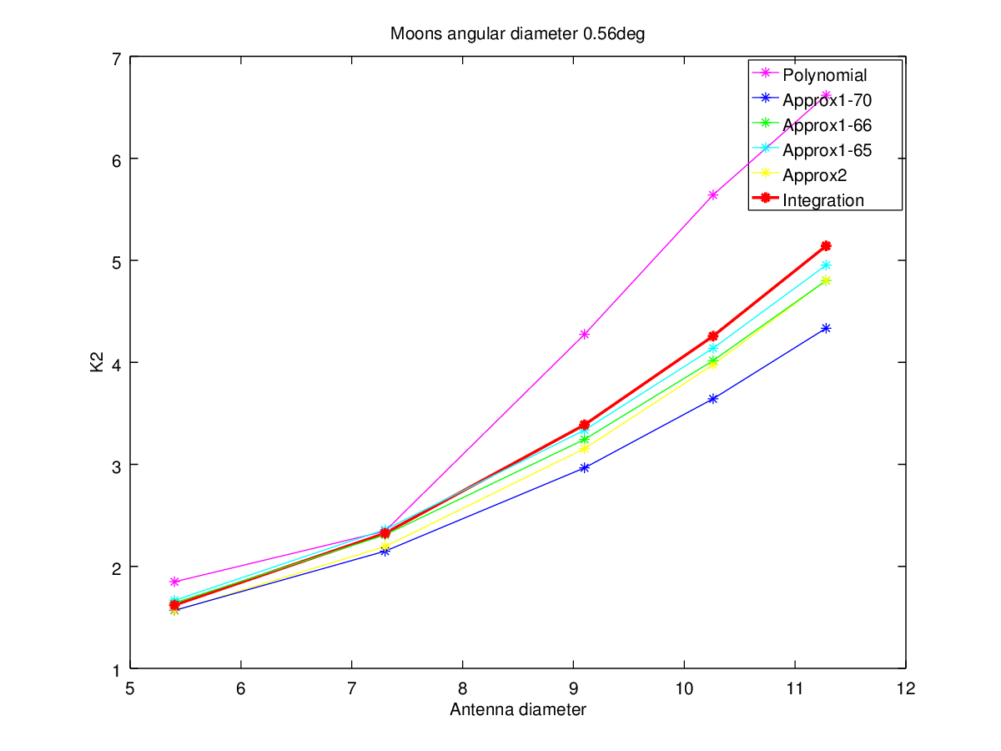

Test 2:
- Frequency: 8.25 GHz
- Edge taper: -15 dB
- Blockage: ON
- Antenna design: Cassegrain (reflector f/D = 0.3)
 | K2: d=0.5°
 | Polynom. | Approx.1  k=70 | Approx.1 k=58.96·(1+0.0125·Te) | Approx.1 k=58.96·(1+0.0107·Te) | Approx.2 | Integration
D=5.4m | 1.6411 | 1.440790 | 1.440580 | 1.463744 | 1.431654 | 1.423525
D=7.3m | 2.0017 | 1.877837 | 1.877396 | 1.926235 | 1.892834 | 1.865033
D=9.1m | 3.4249 | 2.488674 | 2.487897 | 2.573823 | 2.585853 | 2.519243
D=10.26m | 4.5825 | 2.998071 | 2.997016 | 3.113526 | 3.193654 | 3.071917
D=11.28m | 5.4476 | 3.524367 | 3.523033 | 3.670220 | 3.833227 | 3.660750

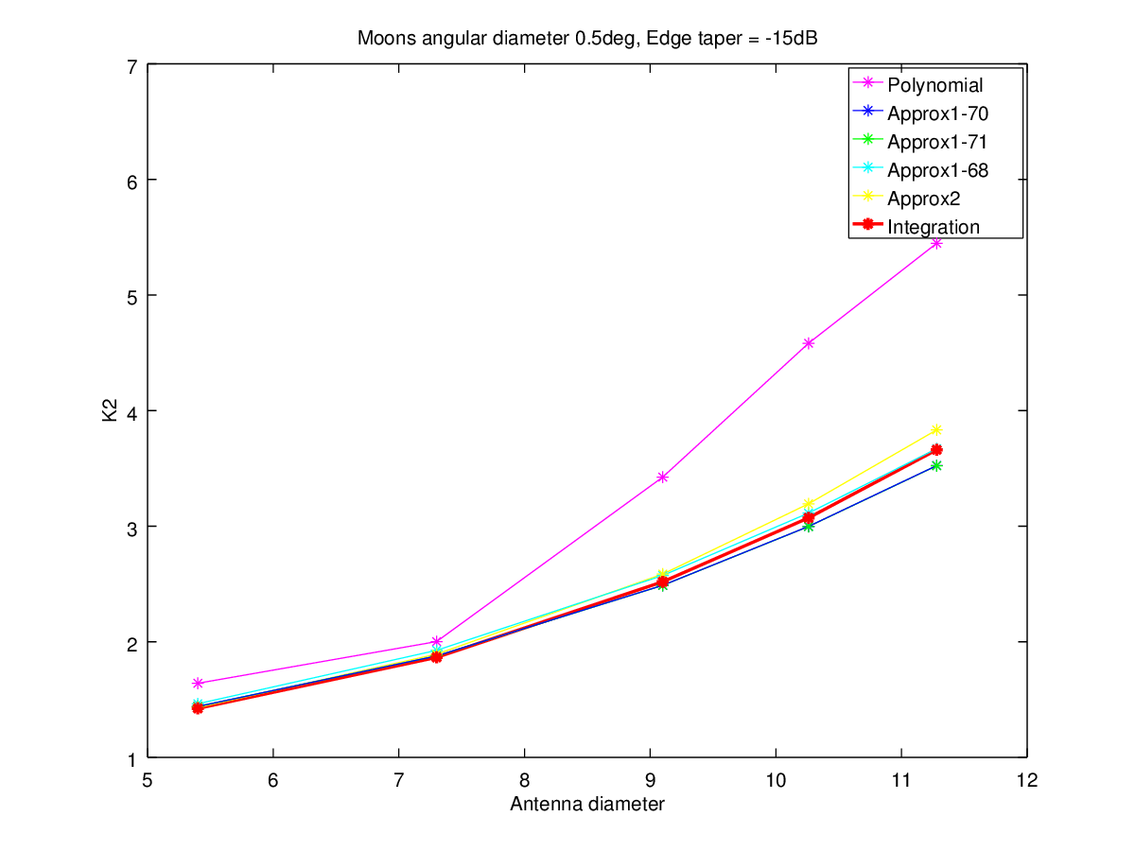

Test 3:
- Frequency: 8.25 GHz
- Edge taper: -10 dB
- Blockage: OFF
- Antenna design: Front Feed (reflector f/D = 1.5)

 | K2: d=0.5°
 | Polynom. | Approx.1  k=70 | Approx.1 k=58.96·(1+0.0125·Te) | Approx.1 k=58.96·(1+0.0107·Te) | Approx.2 | Integration
D=5.4m | 1.6411 | 1.440790 | 1.497140 | 1.515492 | 1.431654 | 1.495669
D=7.3m | 2.0017 | 1.877837 | 1.996921 | 2.035891 | 1.892834 | 2.027442
D=9.1m | 3.4249 | 2.488674 | 2.698219 | 2.766793 | 2.585853 | 2.817384
D=10.26m | 4.5825 | 2.998071 | 3.281908 | 3.374568 | 3.193654 | 3.497375
D=11.28m | 5.4476 | 3.524367 | 3.882435 | 3.998961 | 3.833227 | 4.202437

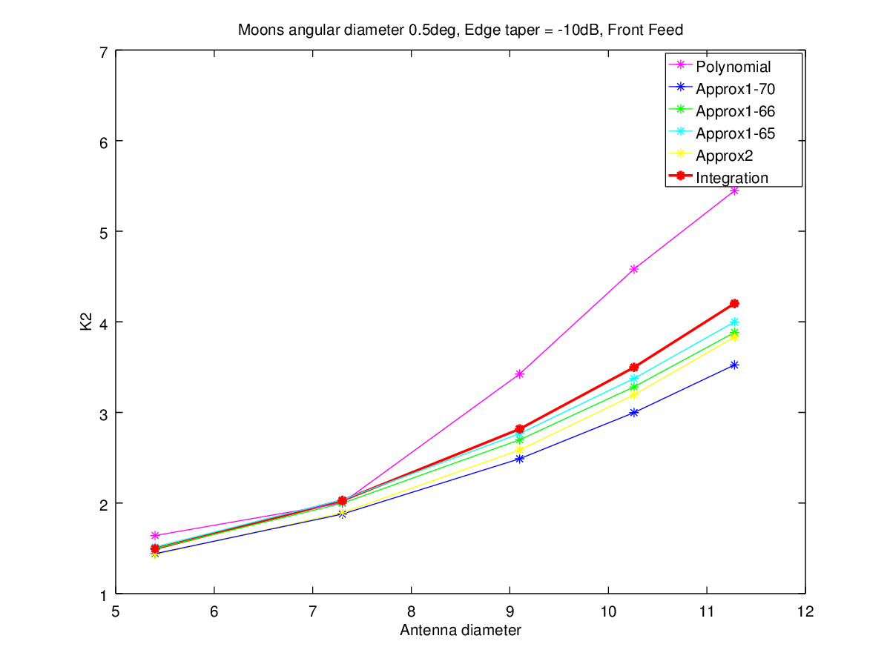

Test 4:
- Frequency: 8.25 GHz
- Edge taper: -15 dB
- Blockage: OFF
- Antenna design: Front Feed (reflector f/D = 1.5)

 | K2: d=0.5°
 | Polynom. | Approx.1  k=70 | Approx.1 k=58.96·(1+0.0125·Te) | Approx.1 k=58.96·(1+0.0107·Te) | Approx.2 | Integration
D=5.4m | 1.6411 | 1.440790 | 1.440580 | 1.463744 | 1.431654 | 1.432414
D=7.3m | 2.0017 | 1.877837 | 1.877396 | 1.926235 | 1.892834 | 1.881754
D=9.1m | 3.4249 | 2.488674 | 2.487897 | 2.573823 | 2.585853 | 2.537953
D=10.26m | 4.5825 | 2.998071 | 2.997016 | 3.113526 | 3.193654 | 3.102206
D=11.28m | 5.4476 | 3.524367 | 3.523033 | 3.670220 | 3.833227 | 3.693291

